_________ ____________
Student ID Student Name

Lab 9: Nested LOOPS in C++

Objective:
The objective of this lab is to understand and implement nested loops in C++. Nested loops involve using one or more loops inside another loop, allowing for more complex control flow and repetitive tasks.
Equipment Needed:
- Computer with a C++ compiler (e.g., g++, Visual Studio)
- Text editor or Integrated Development Environment (IDE)

Introduction: In programming, loops are used to execute a block of code repeatedly. Nested loops, as the name suggests, involve one loop inside another. This structure is beneficial when you need to repeat a set of instructions multiple times, and within each iteration of the outer loop, you want to perform a series of iterations using the inner loop.
Theory: C++ supports several loop structures, including for, while, and do-while loops. When these loops are used inside each other, they form nested loops. The structure of a nested loop looks like this:
Example1:-

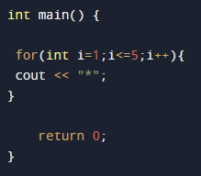

Example2:-

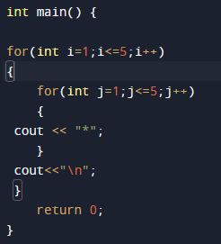

Example3:-

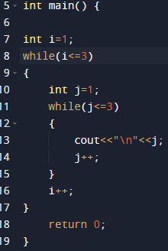

Example4:-

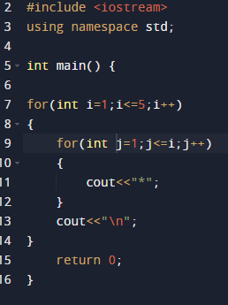

Example5:-

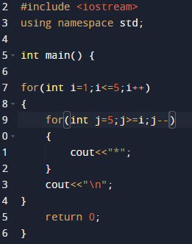

Student Task:

Copy paste these program run it and attach output and also write explanation how it’s working in your own words.
- Program1:-

#include <iostream>
using namespace std;

int main() {
for (int i = 1; i <= 5; ++i) {
for (int j = 1; j <= 10; ++j) {
cout << i * j << "\t";
}
cout<<"\n";
}

return 0;
}

- Program2:-

